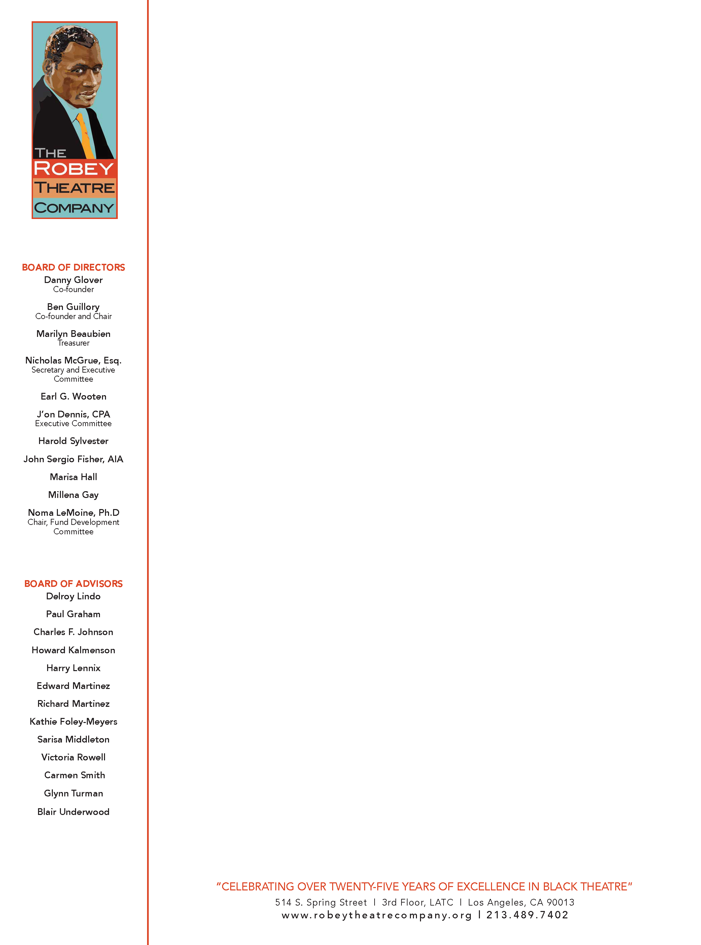
November 15, 2019
Hello Everyone,

The Robey Theatre Company’s Spring Session of the Advance Scene Study Workshop for 2020 begins Monday January 27, 2020 at the

THE VICTORY THEATRE CENTER

THE LITTLE VICTORY Theatre
3324 West Victory Blvd, Burbank, CA 91505
box office: 818.841.5422
Workshop time is 7-10pm. The workshop ends Monday April 6, 2020
Ben Guillory conducts the scene study workshop.
The process begins Monday January 27, 2020 with a 7pm Orientation at the Little Victory Theatre. You’ll meet the other actors; match scene and scene partners and receive a scene presentation schedule. Actors will work out the rehearsal schedule and questions will be answered about scene presentation, etc. Note: It’s extremely important that actors attend this orientation!
The cost is $500.00 *** A payment $250.00 is required January 14, 2020 to secure a seat – Robey accepts 14 actors per session. The balance is due on/before Monday March 9, 2020 Please check your schedule before you make the commitment as it affects others working with you.
2020 Spring Session Dates
Check your schedules:

Mon. Jan. 27 orientation Mon. March 9
Mon. Feb. 3 Scene Presentation Begins Mon. March 16
Mon. Feb. 10 Mon. March 23
Mon. Feb. 17 Mon. March 30
Mon. Feb. 24 Mon. April 6
Mon. March 2

Thank you
Ben Guillory
Producing Artistic Director RTC

